Tail dependence: AUDUSD and USDCAD
Method 19 / daily log returns / alpha=0.05 / Alpari D1 full available history

Study setup
Logical pair: AUDUSD , USDCAD
Broker symbols: AUDUSD_i , USDCAD_i
Snapshot: 2026-11-03_majors_alpari_D1
Timeframe: D1
Matched return window: 1999-01-05 to 2026-11-02 (UTC bar dates)
Matched return count n: 7204
Dropped unfinished last bar dated 2026-11-03 UTC after a tick-volume check against the prior complete day.
Uniforms: ranks/(n+1); alpha=0.05
Complete matched rows (Excel): AUDUSD-USDCAD_Tail_D1.xlsx
Complete matched rows (HTML table): AUDUSD-USDCAD_Tail_D1_data.html

Method carried forward
Tail dependence counts how often both legs sit in an extreme uniform tail together. Matched daily log returns of close, ln(close_t / close_t-1), become u_i = rank(x_i)/(n+1) and v_i = rank(y_i)/(n+1). At alpha=0.05, lower L_hat = (# u<=alpha and v<=alpha) / (# conditioning leg <= alpha); upper uses >= 1-alpha. Both conditioning directions are reported with numerator and denominator counts. Quotes are not inverted. L_hat(0.05) is a finite-sample frequency, not the asymptotic lambda. Same-sample Pearson r is a side check. This is not causation and not a trading signal.

Results
tail | cond | L_hat | num | denom
lower | USDCAD | 0 | 0 | 360
lower | AUDUSD | 0 | 0 | 360
upper | USDCAD | 0.005556 | 2 | 360
upper | AUDUSD | 0.005556 | 2 | 360
Pearson r on returns: -0.647362

Conclusion
Over 7204 matched daily rows for AUDUSD and USDCAD at alpha=0.05, lower L_hat conditioning on USDCAD is 0.0000 (0/360); conditioning on AUDUSD is 0.0000. Upper L_hat conditioning on USDCAD is 0.0056; on AUDUSD is 0.0056. Pearson r = -0.6474. These are finite-sample frequencies, not asymptotic lambda and not a trading signal.

Charts
Daily closes

Daily log returns

Uniforms with alpha lines
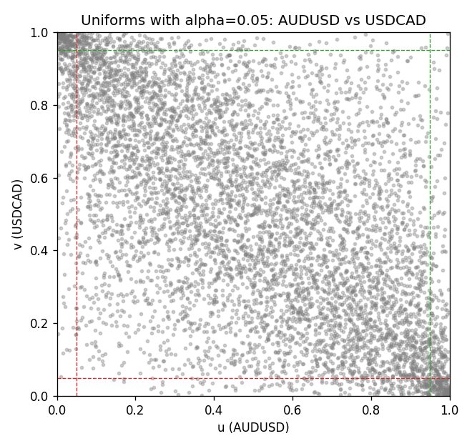

Data report
Every matched row is stored in the sibling Excel workbook named AUDUSD-USDCAD_Tail_D1.xlsx, including u and v. Embedding all rows as a Word table is impractical; this file holds column summaries and the first and last 15 matched rows.
Columns: time, AUDUSD_open, USDCAD_open, AUDUSD_high, USDCAD_high, AUDUSD_low, USDCAD_low, AUDUSD_close, USDCAD_close, AUDUSD_tick_volume, USDCAD_tick_volume, AUDUSD_spread, USDCAD_spread, AUDUSD_real_volume, USDCAD_real_volume, AUDUSD_log_return, USDCAD_log_return, u, v
Column summaries (matched calculation rows)
column | count | mean | std | min | 25% | 50% | 75% | max
AUDUSD_open | 7204 | 0.75193151 | 0.13526075 | 0.4785 | 0.6610425 | 0.731405 | 0.8086175 | 1.10284
USDCAD_open | 7204 | 1.2670146 | 0.16899756 | 0.9168 | 1.118975 | 1.298545 | 1.372225 | 1.6183
AUDUSD_high | 7204 | 0.7559812 | 0.13582551 | 0.4878 | 0.6647 | 0.734785 | 0.81467 | 1.10795
USDCAD_high | 7204 | 1.2719163 | 0.16895637 | 0.9336 | 1.123375 | 1.30394 | 1.3767575 | 1.619
AUDUSD_low | 7204 | 0.74787477 | 0.13457623 | 0.4775 | 0.6577 | 0.727495 | 0.8042 | 1.0975
USDCAD_low | 7204 | 1.2624553 | 0.16903522 | 0.9056 | 1.11435 | 1.293585 | 1.3678925 | 1.6102
AUDUSD_close | 7204 | 0.75197934 | 0.13524694 | 0.4786 | 0.6611975 | 0.731695 | 0.808875 | 1.10169
USDCAD_close | 7204 | 1.2670334 | 0.16897258 | 0.916 | 1.11848 | 1.298615 | 1.372515 | 1.6137
AUDUSD_tick_volume | 7204 | 77316.143 | 138115.43 | 109 | 5421.75 | 43310.5 | 71296.75 | 1234623
USDCAD_tick_volume | 7204 | 80846.476 | 147183.52 | 56 | 5511.25 | 40857 | 71531.75 | 1410818
AUDUSD_spread | 7204 | 30.823709 | 16.885829 | 0 | 13 | 30 | 50 | 50
USDCAD_spread | 7204 | 23.505275 | 18.28107 | 0 | 9 | 17 | 40 | 60
AUDUSD_real_volume | 7204 | 5.2399076e+09 | 1.2535442e+11 | 0 | 0 | 0 | 0 | 3.811512e+12
USDCAD_real_volume | 7204 | 1.8332738e+10 | 9.6584767e+10 | 0 | 0 | 0 | 0 | 2.5751613e+12
AUDUSD_log_return | 7204 | 2.007e-05 | 0.0075444 | -0.08602525 | -0.00386183 | 0.00027895 | 0.00414528 | 0.0806166
USDCAD_log_return | 7204 | -1.21e-05 | 0.00514438 | -0.03859748 | -0.00283637 | 4.97e-05 | 0.00272781 | 0.03436319
u | 7204 | 0.5 | 0.28865509 | 0.00013879 | 0.2500694 | 0.5 | 0.7499306 | 0.99986121
v | 7204 | 0.5 | 0.2886551 | 0.00013879 | 0.2500694 | 0.5 | 0.7499306 | 0.99986121
First 15 matched rows (selected columns)
time | AUDUSD_log_return | USDCAD_log_return | u | v
1999-01-05 | -0.00080418179 | -0.010131666 | 0.43122831 | 0.026786954
1999-01-06 | 0.011836351 | -0.0003306769 | 0.95850104 | 0.46412214
1999-01-07 | 0.0088650256 | 0.0015202092 | 0.91714087 | 0.65149202
1999-01-08 | 0.00031515916 | -0.0020495197 | 0.50256766 | 0.30437196
1999-01-11 | 0.0072213815 | -0.0035137769 | 0.8778626 | 0.20791117
1999-01-12 | -0.0048608485 | 0.0066194721 | 0.2055517 | 0.92463567
1999-01-13 | -0.0078902098 | 0.0045420214 | 0.11131159 | 0.85523942
1999-01-14 | -0.002696916 | 0.0069376546 | 0.31172797 | 0.93171409
1999-01-15 | 0.007123101 | -0.0056905671 | 0.87383761 | 0.10756419
1999-01-18 | 0.00094592471 | 0.00098344542 | 0.54698126 | 0.59708536
1999-01-19 | 0.0072225153 | 0.002748513 | 0.87800139 | 0.75156142
1999-01-20 | 0.0012507819 | -0.0059646885 | 0.56710618 | 0.099097849
1999-01-21 | 0.00078094498 | -0.0042823796 | 0.53573907 | 0.16210965
1999-01-22 | -0.012252745 | 0.0025057712 | 0.043997224 | 0.73365718
1999-01-25 | -0.0039591468 | 0.00085579808 | 0.24496877 | 0.5851492
Last 15 matched rows (selected columns)
time | AUDUSD_log_return | USDCAD_log_return | u | v
2026-10-13 | 0.0035007712 | -0.0046395653 | 0.7129771 | 0.14934074
2026-10-14 | -0.0015193215 | 0.0015184751 | 0.38237335 | 0.65135323
2026-10-15 | -0.0075447063 | -0.0036101503 | 0.11797363 | 0.20208189
2026-10-16 | 0.0033906408 | -0.0034322068 | 0.70714781 | 0.21346287
2026-10-19 | 0.0050859986 | -0.0018835331 | 0.79541985 | 0.31880638
2026-10-20 | 0.0034620426 | -0.0037066008 | 0.71089521 | 0.19514226
2026-10-21 | 0.0036066384 | -0.00084691787 | 0.71977793 | 0.41415684
2026-10-22 | -0.0012672558 | -0.0026307268 | 0.40027759 | 0.26537127
2026-10-23 | 0.0023765656 | 2.85545e-05 | 0.63858432 | 0.49882026
2026-10-26 | -0.0032032829 | 5.7106554e-05 | 0.28313671 | 0.50076336
2026-10-27 | 0.0016669876 | 0.0025379458 | 0.59139486 | 0.7369882
2026-10-28 | 0.0040915541 | -0.0038379274 | 0.74725885 | 0.18556558
2026-10-29 | -0.0040915541 | -0.00011436495 | 0.23941707 | 0.48424705
2026-10-30 | 0.0010102376 | -0.0010298736 | 0.55017349 | 0.39583622
2026-11-02 | -0.0049184984 | 0.00061519094 | 0.20291464 | 0.56044414

